- DNS SERVER CONFIGURATION ASSIGNMENT
Q1. Install and set up a DNS server on your local machine using Simple DNS Plus (Windows), then create a new DNS zone for the domain musicmania.in.
To install and configure a DNS server on the local Windows machine and create a primary DNS zone for musicmania.in.
Procedure:
1. Install Simple DNS Plus on the Windows computer and open it as Administrator.
2. Open the DNS Records window and choose New Zone.
3. Select Primary Zone / Forward Zone.
4. Enter musicmania.in as the zone name and finish the wizard.
5. Confirm that musicmania.in appears in the list of local zones.
Result:
The local DNS server was configured and the primary zone musicmania.in was
created successfully.
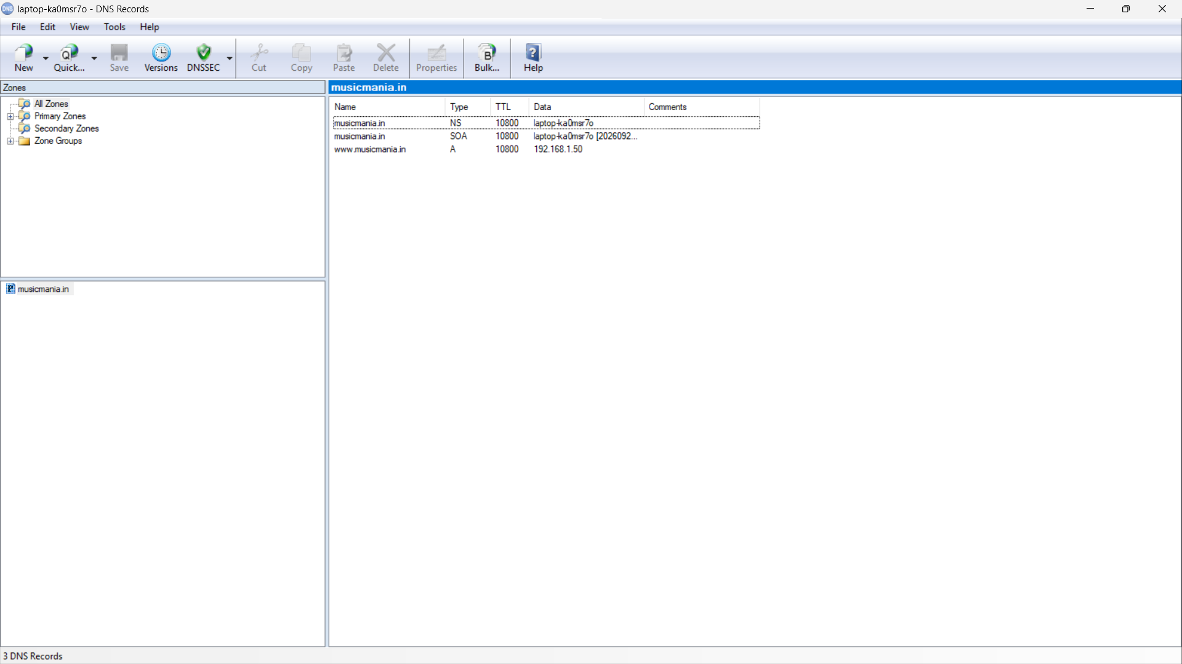
Q2. Add an A record to map www.musicmania.in to 192.168.1.50, then use nslookup to verify the mapping.
Procedure:
1. Select the musicmania.in zone in Simple DNS Plus.
2. Choose New Record and select A (Host Address).
3. Enter www as the host name.
4. Enter 192.168.1.50 as the IPv4 address and save the record.
5. Clear the Windows DNS resolver cache.
6. Query the local DNS server directly with nslookup.
ipconfig /flushdns
nslookup www.musicmania.in 127.0.0.1
Expected verification:
Name: www.musicmania.in
Address: 192.168.1.50
Result:
The A record was created successfully and www.musicmania.in resolved to 192.168.1.50.
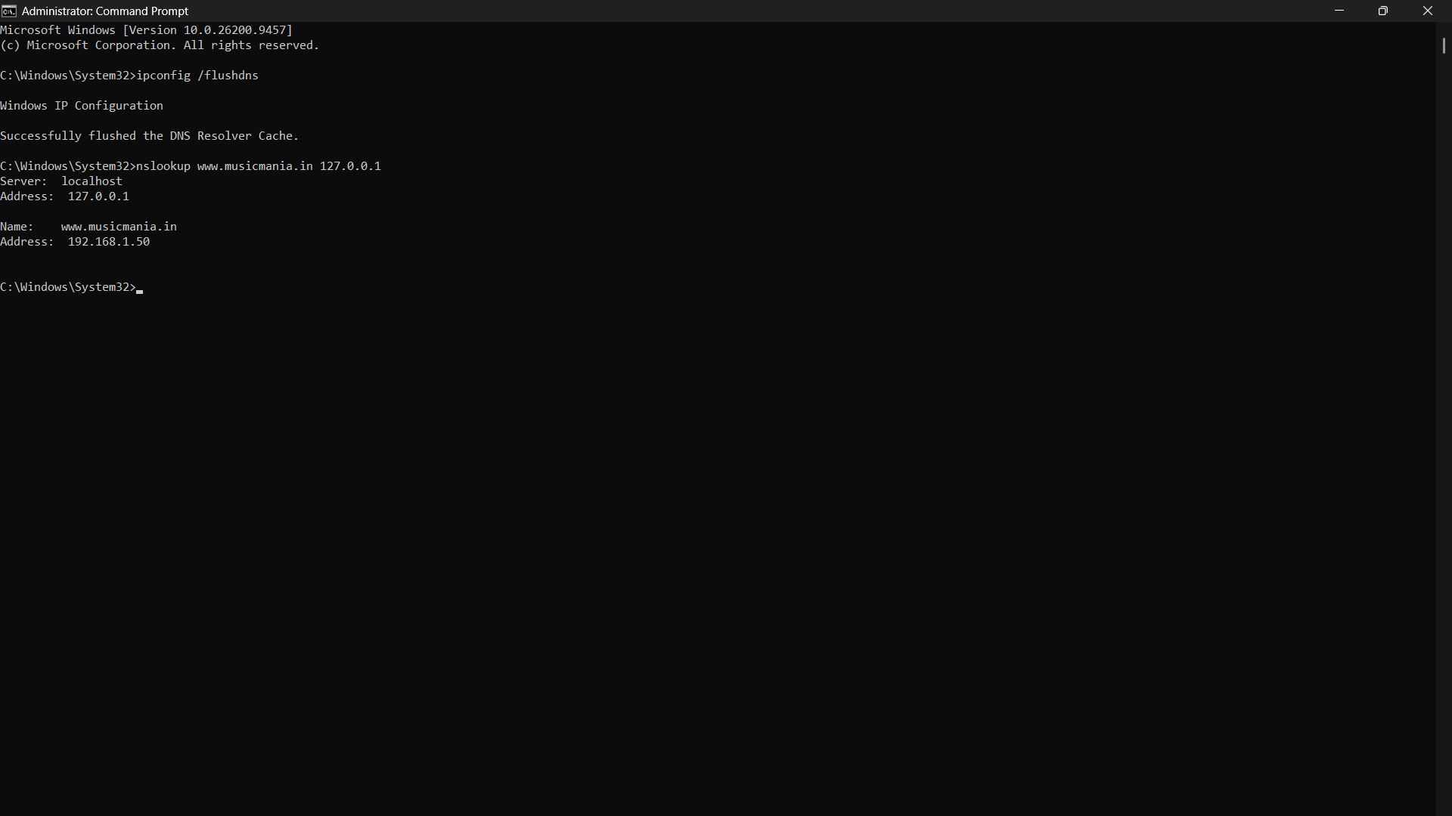
Q3. Add a CNAME record for play.musicmania.in pointing to www.musicmania.in, then test that it resolves to the correct IP address.
Procedure:
1. Select the musicmania.in zone.
2. Choose New Record and select CNAME (Alias).
3. Enter play as the alias/name.
4. Set the target/canonical name to www.musicmania.in.
5. Save the CNAME record.
6. Flush the DNS cache and test the alias against the local DNS server.
ipconfig /flushdns
nslookup play.musicmania.in 127.0.0.1
nslookup -type=CNAME play.musicmania.in 127.0.0.1
Expected configuration:
www A 192.168.1.50
play CNAME www.musicmania.in.
Result:
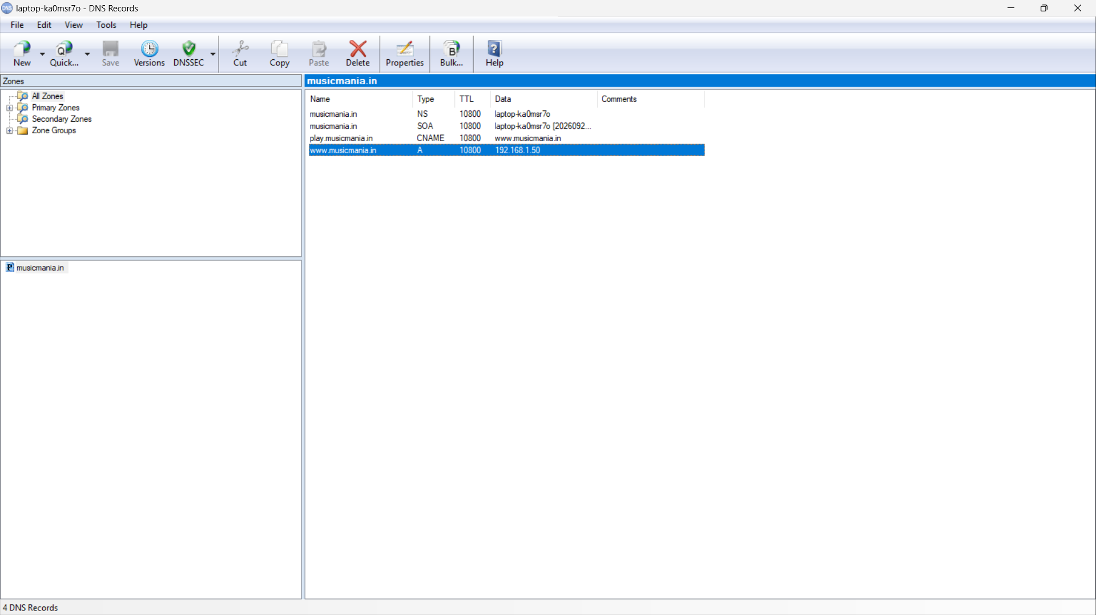
The CNAME record was created successfully. play.musicmania.in points to www.musicmania.in, which resolves to 192.168.1.50.
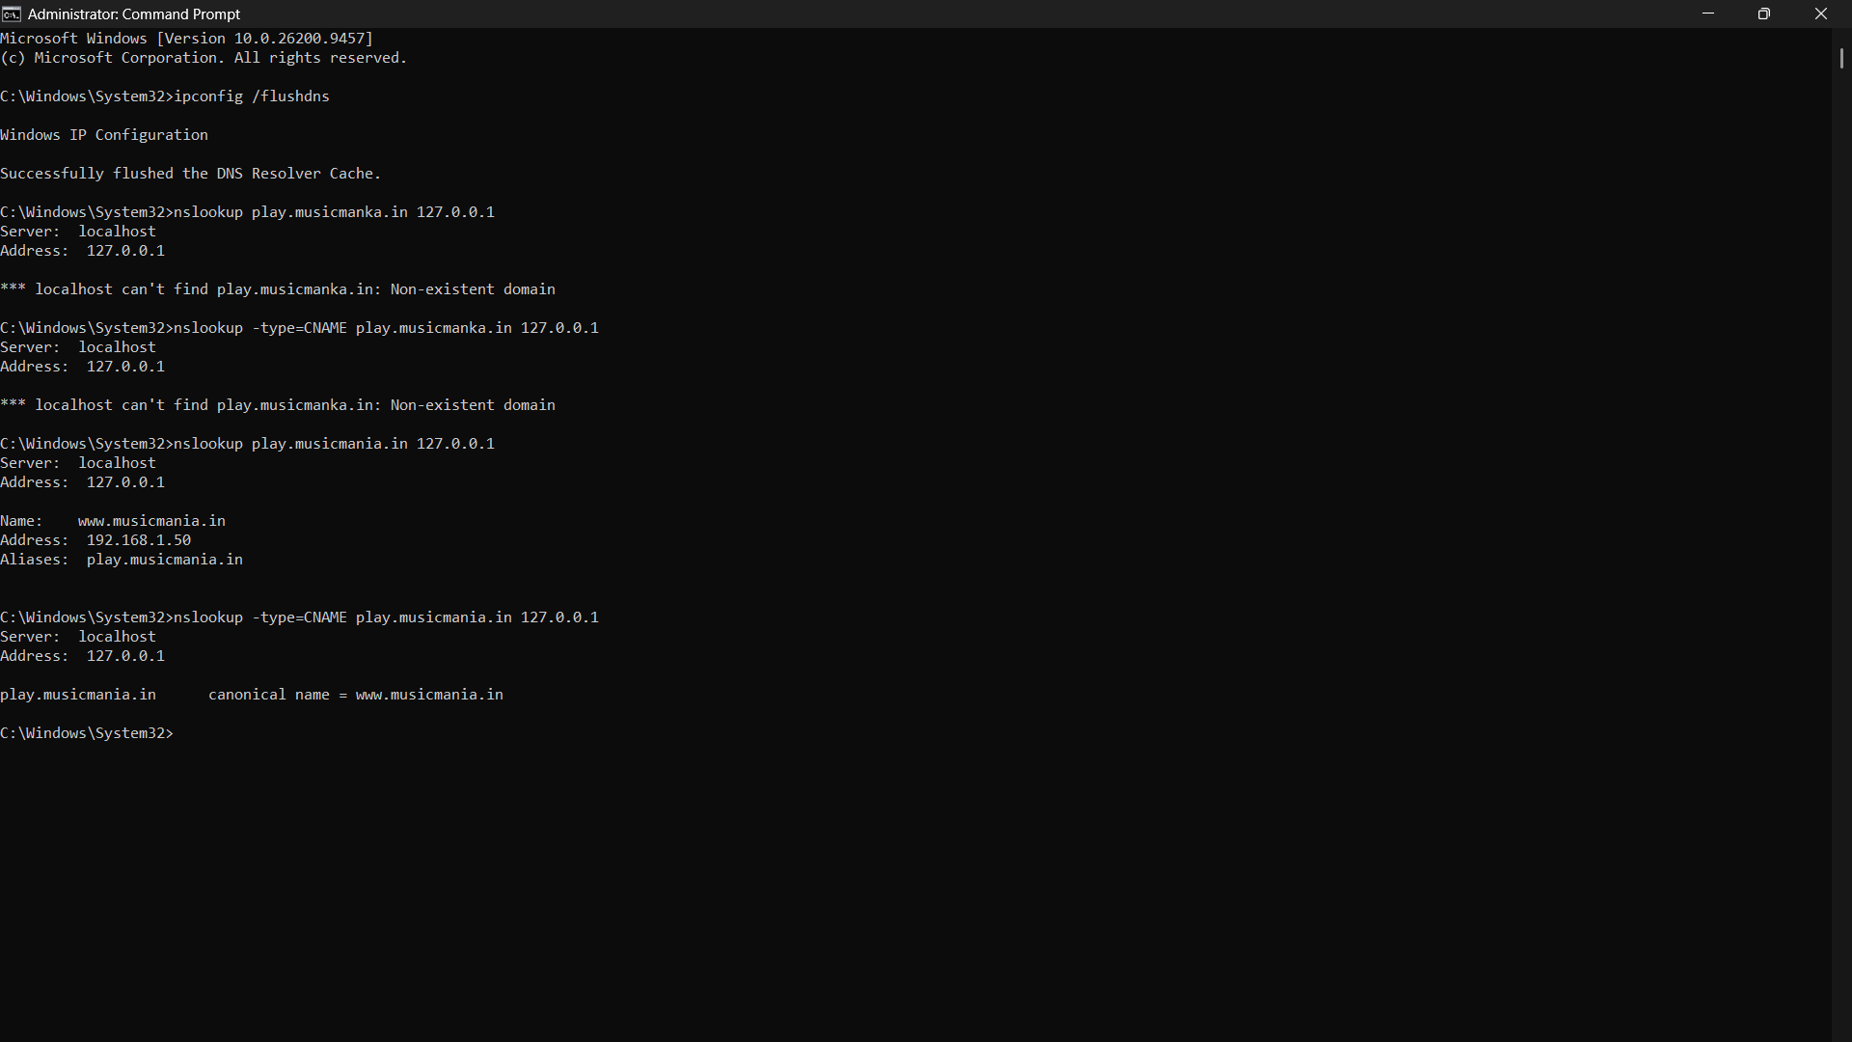
Q4. The DNS server is not resolving musicmania.in as expected. Document the troubleshooting process, including configuration checks, restarting DNS, and testing with nslookup.
Troubleshooting Steps:
1. Check the DNS zone
Confirm that musicmania.in exists and is enabled in Simple DNS Plus.
2. Check DNS records
Verify that the A record is www → 192.168.1.50 and the CNAME is play → www.musicmania.in.
3. Check DNS port 53
Run the command below to confirm that a DNS service is listening.
netstat -ano | findstr ":53"
4. Clear the DNS cache
Remove any old cached DNS result from Windows.
ipconfig /flushdns
5. Test the A record
Query the local DNS server directly.
nslookup www.musicmania.in 127.0.0.1
6. Test the CNAME
Check that the alias exists and resolves correctly.
nslookup play.musicmania.in 127.0.0.1
nslookup -type=CNAME play.musicmania.in 127.0.0.1
7. Check Windows network settings
Use ipconfig /all and review the IPv4 address, gateway and DNS server values.
ipconfig /all
8. Restart the DNS server
Stop and start/restart Simple DNS Plus, then repeat the nslookup tests.
Final Configuration:
Name | Type | Value
www | A | 192.168.1.50
play | CNAME | www.musicmania.in.
Conclusion:
The local Windows DNS server can be tested directly through 127.0.0.1. Checking the zone, records, port 53, DNS cache and nslookup results helps identify and fix common DNS resolution problems.
